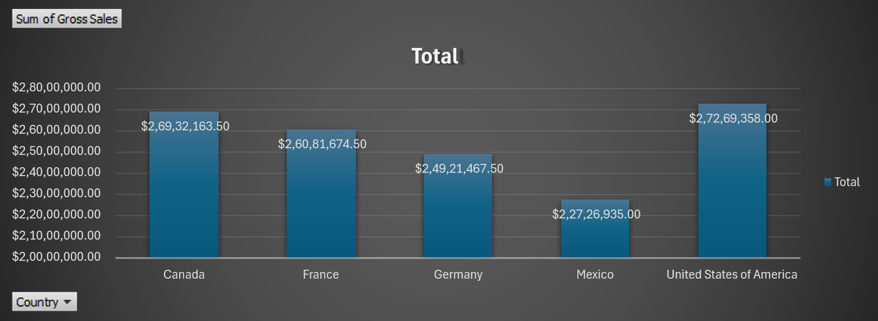

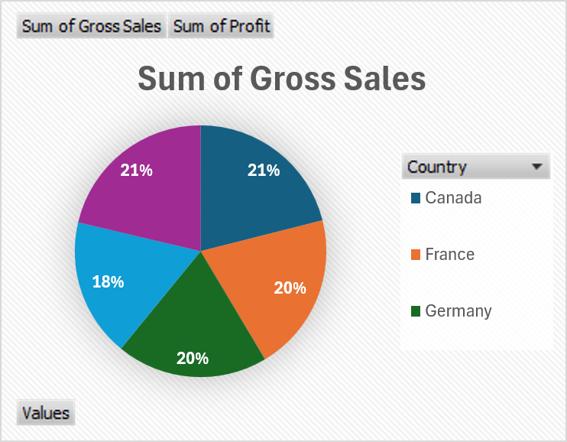

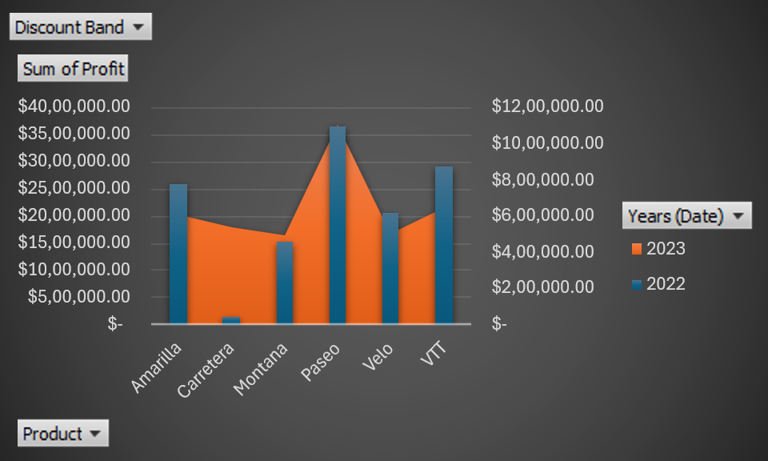
Discount Band | (All)
Sum of Profit | Column Labels
Row Labels | 2022 | 2023 | Grand Total
Amarilla | $ 7,81,949.53 | $ 20,32,154.53 | $ 28,14,104.06
Carretera | $ 38,768.86 | $ 17,88,036.03 | $ 18,26,804.89
Montana | $ 4,57,758.04 | $ 16,56,996.84 | $ 21,14,754.88
Paseo | $ 10,99,853.09 | $ 36,97,584.86 | $ 47,97,437.95
Velo | $ 6,21,949.76 | $ 16,84,042.71 | $ 23,05,992.47
VTT | $ 8,78,185.23 | $ 21,56,422.79 | $ 30,34,608.02
Grand Total | $ 38,78,464.51 | $ 1,30,15,237.75 | $ 1,68,93,702.26

Row Labels | Sum of Gross Sales | Sum of Profit
Canada | $ 2,69,32,163.50 | $ 35,29,228.89
France | $ 2,60,81,674.50 | $ 37,81,020.78
Germany | $ 2,49,21,467.50 | $ 36,80,388.82
Mexico | $ 2,27,26,935.00 | $ 29,07,523.11
United States of America | $ 2,72,69,358.00 | $ 29,95,540.67
Grand Total | $ 12,79,31,598.50 | $ 1,68,93,702.26

Row Labels | Sum of Gross Sales
Canada | $ 2,69,32,163.50
France | $ 2,60,81,674.50
Germany | $ 2,49,21,467.50
Mexico | $ 2,27,26,935.00
United States of America | $ 2,72,69,358.00
Grand Total | $ 12,79,31,598.50

